**Geology Notes:**

Geology: the study of the earth, what it’s made of, and how it came to look the way it does. This includes looking at chemistry, physics, and biology to understand some of the forces at work.

Scientific Observations: a fundamental aspect of the scientific method, which involves gathering empirical evidence through careful and systematic observation of natural phenomena. It entails using the senses or scientific instruments to perceive and record data about the world around us. An important part of scientific observation is that it observes without interacting with what is being observed.

Scientific Method: a systematic approach used by scientists to investigate natural phenomena, acquire new knowledge, or solve problems. It involves a series of steps designed to ensure objectivity, reliability, and reproducibility in the process of scientific inquiry. While there are variations in how the scientific method is applied, it generally includes the following key steps:

* Observe
* Question
* Hypothesize
* Predict
* Experimentation or Observation
* Collect Data & Analyze
* Conclude
* Communicate

Hypothesis: a tentative and testable explanation or prediction proposed to answer a specific question or address a particular problem in science. It serves as a starting point for scientific investigation and forms the basis for designing experiments or making observations to gather empirical evidence.

Empirical Evidence: the information obtained through observation and documentation of certain behavior and patterns or through an experiment.

The foundation of geology focuses on the study and examination of rocks. There are three basic types:

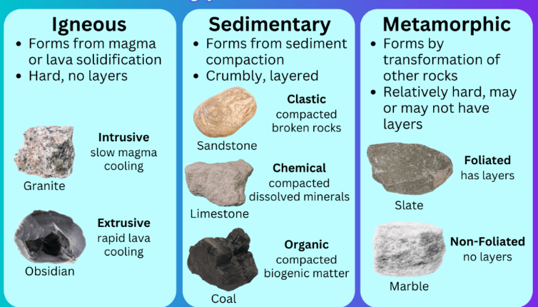

The rock cycle is the process one rock goes through to transform into another type of rock.

Plate tectonic theory: The system of ideas behind plate tectonics theory suggests that Earth's outer shell (lithosphere) is divided into several plates that glide over the Earth's rocky inner layer above the soft core (mantle).

Exactly how the earth’s crustal plates interact is determined by the type of motion and type of crustal material. These are the types of plate boundaries:

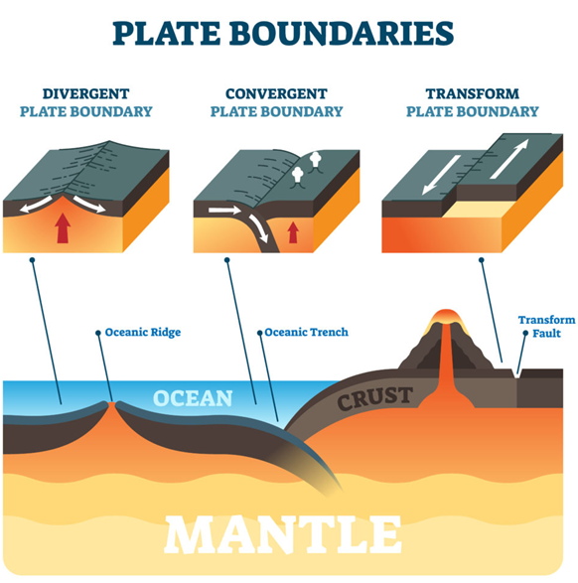

At convergent boundaries, two crustal plates are moving toward one another and come together.

At divergent plate boundaries, two crustal plates are separating or moving apart from one another.

At transform boundaries, the two plates are neither colliding nor separating; they are simply sliding alongside one another.

There are three types of forces thought to drive plate tectonics:

* Ridge Push: This force is generated at the mid-ocean ridges, where new oceanic crust is created through the upwelling of molten rock material (magma) from the Earth's mantle. As the hot magma cools and solidifies, it forms new oceanic crust, causing the adjoining tectonic plates to move away from the ridge. The elevated temperature and lower density of the newly formed crust at the ridge exert a pushing force on the surrounding plates, contributing to their movement.
* Ridge Push: This force is generated at the mid-ocean ridges, where new oceanic crust is created through the upwelling of molten rock material (magma) from the Earth's mantle. As the hot magma cools and solidifies, it forms new oceanic crust, causing the adjoining tectonic plates to move away from the ridge. The elevated temperature and lower density of the newly formed crust at the ridge exert a pushing force on the surrounding plates, contributing to their movement.
* Ridge Push: This force is generated at the mid-ocean ridges, where new oceanic crust is created through the upwelling of molten rock material (magma) from the Earth's mantle. As the hot magma cools and solidifies, it forms new oceanic crust, causing the adjoining tectonic plates to move away from the ridge. The elevated temperature and lower density of the newly formed crust at the ridge exert a pushing force on the surrounding plates, contributing to their movement.

Rocks are constantly being moved around on Earth’s surface. Surface processes in geology include changes due to gravity, water, ice, wind, and waves. These forces sculpt Earth’s surface, creating landforms and landscapes in ways that are much easier to observe than the more expansive processes of rock formation and tectonic movement.

Rock dating: provides ages of rock layers in relation to one another. There are 3 principles here: lower layers are older, all sedimentary rock layers originally formed in a horizontal position, and where a different rock type cuts through a layer, the cross-cutting rock is younger than the layers it crosses through.

Absolute dating of rocks uses radioactive atoms called isotopes to determine age in numerical years.

Geologic timescale: a sequence of Earth’s geological history separated into different spans of time.

Evolution basically means to change over time.

Fossilization is the term used to describe when dead life forms are preserved in rock layers.

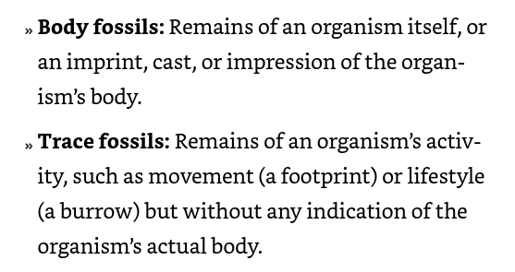

Mass Extinction Events: refers to a period in Earth's history when an unusually large number of species went extinct in a geologically short period of time. These events are characterized by a sharp decline in biodiversity and the disappearance of a significant portion of the planet's plant and animal life.

Manipulative experiments are experiments done in laboratories where the scientist can manipulate or change certain factors in order to determine what factors are important in the observed outcome.

A scientific experiment, whether it is a natural or manipulated experiment, must be repeatable. This means that the scientists must clearly describe the steps they have taken so that another scientist can repeat the same experiment and see if she too, gets the same result.

Data: refers to facts, statistics, or any other pieces of information, especially when processed, analyzed, or stored by computers. Data can take various forms, such as numbers, text, images, audio, or video. It can be structured (organized in a specific format, like tables or databases) or unstructured (not organized in a pre-defined model, like text documents or multimedia files).

Statistics are a mathematical tool for describing and comparing information (observations) quantitatively, which simply means using numbers. By using numbers to describe the data, such as the number of times a certain characteristic is observed in different rock samples, scientists can organize and compare the patterns in the data using simple arithmetic. Some statistics determine if two sets of data have overall similarities or differences. Others determine which variables are most important in creating the observed outcomes.

Chart types used to visual data in statistical analysis include: line graphs, pie graphs, bar charts, and scatterplots.

Peer review: means that other qualified and respected scientists have examined the experimental design and procedure, perhaps tested it themselves, and determined that the results and interpretation are reasonable.

Scientific theory: a well-substantiated explanation of some aspect of the natural world that is acquired through the scientific method and repeated testing and confirmation through observation and experimentation.

A scientific law describes an observed action that, when repeated many times, is always the same.

A well-tested and generally accepted theory is considered true even though it may still be tested by the proposal of new hypotheses and experimentation. In some cases, part of a theory may be shown to be untrue, in which case the theory will be adjusted to accommodate this new truth without the entire theory being called into question.

Scientific paradigms are patterns that serve as models for further research. Paradigms, like theories, may change with new information; the change is called a paradigm shift. A paradigm shift brings a new perspective — a whole new way of looking at things.

A laminated rock layer refers to very thinly bedded or finely layered sedimentary rock that exhibits parallel laminations or layers. Variations in this type of rock layer can be caused by:

* Water flow velocity or turbulence
* Sediment supply
* Sediment grain size
* Chemical composition of the depositing solution

A foliated rock layer refers to a type of metamorphic rock that displays a banded or layered appearance due to the parallel arrangement of certain mineral grains within the rock.

Rock composition is the term used to discuss what minerals a rock is made of.

Both gabbro and basalt are dark-colored rocks with the same mineral composition. They both are formed by the cooling of liquid rock (magma or lava) into a solid. Gabbro is formed when the liquid rock cools underground, slowly, over a long period of time. Basalt is formed when liquid rock cools very quickly, at or near the surface of the earth where it is exposed to air or water.

The early belief that earth’s features were created by a series of catastrophic events is called catastrophism. This also allowed for reconciliation between events in the bible and some geologic events. This belief has now largely been discredited since we know the Earth is far older than biblical timeframes.

Two early theories about where rocks come from. While both contain some truths, neither is completely correct:

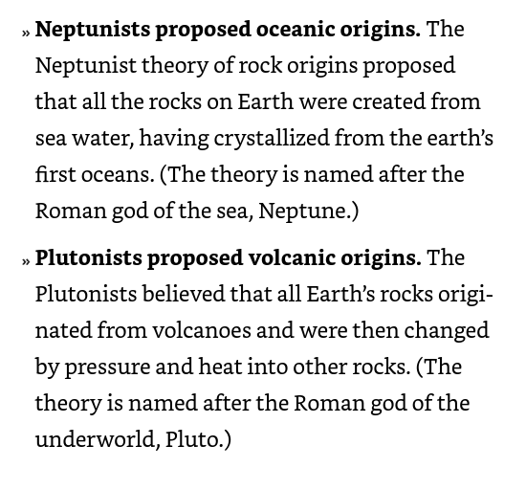

Paleontology is the scientific study of prehistoric life forms on Earth through the examination of plant and animal fossils. It is one of the main subfields of geology.

Stratigraphy is the branch of geology that studies rock layers (strata) and layering (stratification). It is primarily used to understand the timing and relationships of rock layers and the processes that created them. There are four principles:

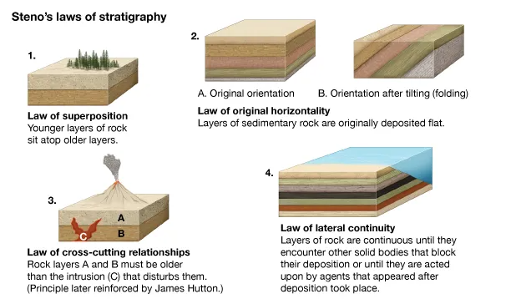

According to Hutton, with a long enough period of time, even the small, commonplace processes that shape the earth’s surface today could result in the dramatic formations previously assumed to be the results of catastrophe.

Deep time refers to the expansive timescales used to describe events in the geological past and the processes that have shaped the Earth over billions of years. It encompasses the vast age of the Earth, dating back around 4.54 billion years, and the enormously long periods over which planet-altering phenomena like continental drift, mountain formation, and evolution of life occurred.

Uniformitarianism: assumes that the geological forces and processes we observe today (erosion, sedimentation, volcanic activity, etc.) have been consistent throughout Earth's history and can be used to interpret geological evidence from the past.

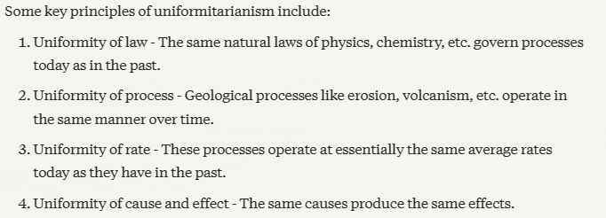

Continental drift- the theory that continents had once been connected and had drifted apart and that the continental movement is based on rock, fossil, and stratigraphic evidence.

Rift: refers to an elongated valley or trough formed by the splitting apart or divergence of tectonic plates in the Earth's lithosphere (the crust and upper mantle).

Seafloor spreading: the process by which new oceanic crust is created at mid-ocean ridges as tectonic plates slowly move away from each other.

Scientists never stop exploring, of course, so even with a well-accepted, well-tested explanation of how the surface of the earth constantly transforms, they don’t stop asking questions.

The snowball earth hypothesis: proposes that at some point- between approximately 600 million and 1 billion years ago- the entire planet was covered with ice. Some of the evidence to support this hypothesis includes rock formations that are the result of massive layers of ice covering the continents near the equator (at that time).

Much research is focused on looking for early warning signs of an impending quake, with the hope that we could use early warning systems to initiate evacuations and reduce the damage to human lives that occurs with such events. Current research around the Pacific Ocean focuses on trying to measure the amount of strain being put on two crustal plates as they press against one another.

Scientists called paleoclimatologists take long, cylinder-shaped samples called cores from ice sheets. In these ice cores, they find trapped gases and dust from the ancient atmosphere that provide clues to the earth’s temperatures long ago. These remains of plant and animal life help scientists called paleoecologists build a picture of the ancient environment and past climates.

By combining multiple records and including different types of data, paleoclimatologists and paleoecologists build a picture of climate change throughout Earth’s history.

An astrogeologist is a scientist who studies the geology of planets, moons, asteroids, comets, and other celestial bodies in the solar system.

The materials of Earth’s planetary system can be separated into spheres, or parts.

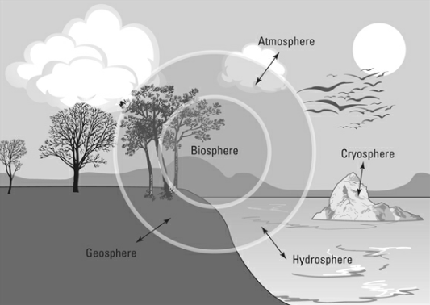

Erosion: the process by which the surface of the Earth is worn away by the action of water, wind, ice, and gravity. It is a crucial geological process that shapes landscapes over time.

A climate system is a complex network of interacting components that influence the Earth's climate and weather patterns. It consists of several sub-systems, including the atmosphere, hydrosphere, cryosphere, lithosphere, and biosphere, all of which are interconnected and continuously exchanging energy and matter.

Every system needs energy to fuel its processes. Systems on Earth’s surface are fueled by heat energy from the sun, whereas other systems (particularly those in the geosphere) are fueled by heat energy that originates deep within the earth.

Humans do not yet have technology advanced enough to dig more than about 12 kilometers (about 7.5 miles) into the earth’s crust.

One way scientists separate the layers of Earth’s geosphere is by physical properties, or whether the layers are liquid or solid.

Two types of seismic waves, called S waves and P waves, are used by scientists to learn about the interior of the earth. These seismic waves are recorded by instruments called seismometers. P waves travel quickly through solid materials and slow down, slightly changing direction, as they move through liquid materials. S waves travel through solid materials but cannot travel through liquid at all.

The areas on the other side of the globe where P waves or S waves do not appear because they either disappear or are refracted (change direction) are called shadow zones.

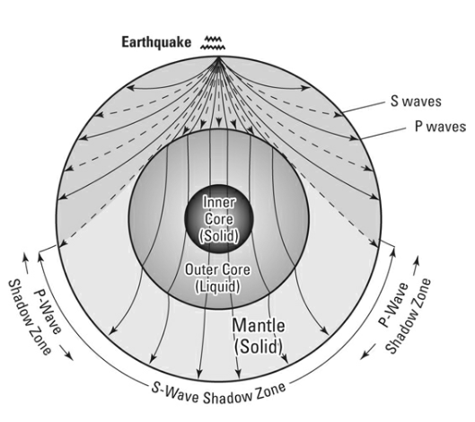

Another way scientists categorize the layers of Earth’s geosphere is by their composition, or the types of elements and minerals that are found in each layer.

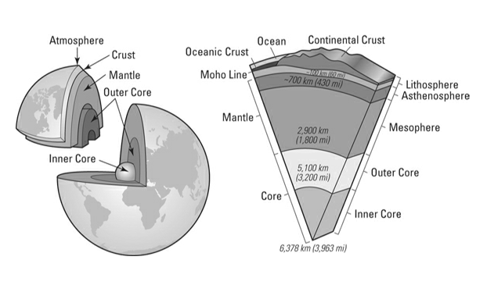

Earth’s core is believed to mostly contain nickel and iron and is composed of two layers. The inner core earth is probably solid and starts at approximately about 3,200 miles from the earth’s surface. The outer core surrounds the inner core and is composed of a liquid layer of heavy metals and begins about 1,795 miles into the earth.

Geophysicists use laboratory studies of iron under conditions of extreme pressure to estimate how hot it may be at such depths. Their estimates range from 5,000 degrees Fahrenheit to 15,000 degrees Fahrenheit.

Outside the earth’s metal core is a layer of rock composing the mantle. Mantle materials are made of minerals that combine light elements (such as silica and oxygen) with heavier elements (such as iron and magnesium). The mantle layers are:

* Mesosphere- This layer of the mantle begins about 410 miles below Earth’s surface
* Asthenosphere- This layer has a plastic flow and begins about 124 miles below Earth’s surface
* Lithosphere- This layer is brittle and about 62 miles thick and is just under the Earth’s crust

Moon rocks are mostly basalt and, interestingly, seem to also contain elements from the Earth’s crust. We’re still trying to figure out whether the moon was once part of Earth that was knocked off, or was just built of similar material left over after Earth formed.

Earth’s crust is made up of two different types of crust: Continental crust that are primary granites, and the oceanic crust under the oceans which are primarily basalt and gabbro.

The line where the material in Earth’s lithosphere changes from the crustal rock to the mantle rock is named the Moho line after the Croatian seismologist that made the discovery.

The science of chemistry explores and describes the properties of substances — gas, liquid, or solid — and explains how and why different substances interact with each other.

An atom is the smallest bit of matter that can be measured and identified as a specific element.

Atoms themselves are composed of smaller, subatomic particles called neutrons, protons, and electrons.

the electrons surround the nucleus, organized into orbital shells. The innermost orbital shell of any atom contains no more than two electrons; the second orbital shell contains no more than eight; and each of the outer shells, while chemically stable with eight electrons, can hold more.

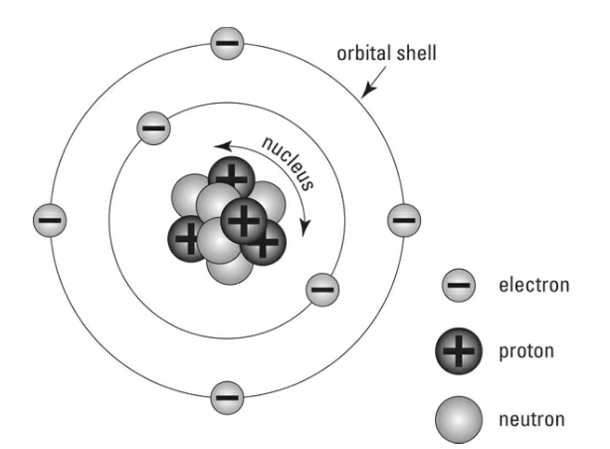

The number of protons in an atom’s nucleus determines which element the atom is.

Each square on the periodic table provides you with all the information you need to know about that element and how it will interact with other elements.

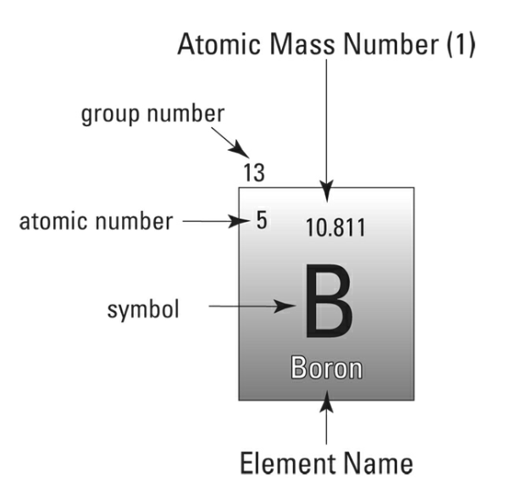

The atomic mass number of an element is the total number of protons and neutrons in its nucleus.

The atomic number of an element is the number of protons in its nucleus.

The group number tells you how many electrons in the atom are located in the outermost orbital shell and are, therefore, available to bond it to other atoms.

The letters on the periodic table are the symbols for each element.

Some periodic tables also list the name of the element below the symbol.

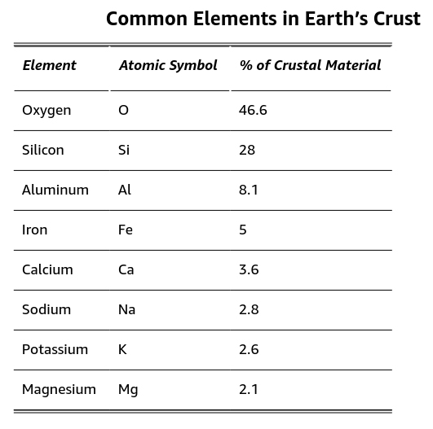

As long as the number of protons stays the same (the atomic number), you have the same element, but its atomic mass changes with the addition or subtraction of neutrons. These various atoms of the same element with different atomic mass numbers are called isotopes.

Each subatomic particle in an atom has a charge, similar to the way opposite ends of a battery or magnet are charged: positive or negative. In an atom, the protons are positive, the neutrons are neutral (no charge), and the electrons are negative.

Atoms or molecules (more than one atom joined together) with positive or negative charge are called ions. The charge of the ion is determined by how the electrons in its outer shell move to and from nearby atomic shells. An atom with a positive charge is called a cation, and an atom with a negative charge is called an anion.

Multiple atoms joined together are called molecules.

Atoms of two or more different elements combine to form a compound. The compound is held together by a chemical bond.

When two atoms trade electrons between their outer orbital shells, becoming a cation and an anion, they form an ionic bond. The result of an ionic bond is that the positively charged cation and negatively charged anion combine into a compound that has a neutral charge. All ionic bonds create compounds called salts.

In a covalent bond the atoms share the electrons in their outer orbital shells. The sharing of electrons in covalent bonding creates a very strong bond because each atom participating in the electron share has a full outer shell and a neutral charge.

Metallic bonds occur between atoms that have very few electrons in their outermost electron shells. Instead of donating or sharing these electrons, the electrons are released from the orbital shell and available for a nearby cluster of atoms to use. The unique nature of metallic bonds is what gives metals such as gold or silver their unique characteristics. The ability to conduct electrical current is a result of the movement of electrons. The shiny, or metallic appearance is due to the large number of freely floating electrons. And the fact that metals can be bent and molded without breaking is also a result of the movement of electrons between atoms in the metallic bond.

The chemical formula of a compound describes the number of different atoms of each element that are combined into a compound.

In the case of geology, most chemical formulas describe minerals, which are solid structures built of molecules.

Every mineral is a combination of elements; the atoms are organized into geometric structures called crystals. Minerals are inorganic, meaning they are not built of the carbon-based organic compounds that make up living tissue in plants and animals.

Earth materials that form without this orderly crystalline structure are described as amorphous or glassy and are not minerals, though they do form certain rocks, like chert and obsidian.

Chemical composition: a combination of elements that creates its particular crystal structure.

A three-dimensional shape formed by bonded atoms is the crystal structure (sometimes called the crystal lattice) of the mineral.

Which minerals make up a rock depend on which elements are present, as well as the conditions of temperature and pressure where the rock was formed.

Properties of a mineral are the physical characteristics of the substance. These include:

* Transparency- characteristic of a mineral is its ability to transmit light, or allow light to pass through it. This property is sometimes called its clarity. A mineral that you can see through is transparent. A mineral that allows light to pass through but is not clear enough to see through is translucent. And a mineral that no light passes through is opaque.
* Color- Color is a result of how light is absorbed or reflected by an object. The least reliable way to identify a mineral.
* Luster- A description of how the surface reflects light. Luster is either metallic (shiny like a metal) or nonmetallic. Nonmetallic lusters include pearly, glassy, silky (like silk fabric), satin, earthy (dull), greasy, or adamantine (extremely shiny, or fiery like a diamond).
* Streak-How the mineral appears in powdered form. To test the streak of a mineral, you rub the mineral on a streak plate, which is a piece of rough porcelain. Rubbing the mineral against a streak plate grinds off some of the mineral into a powdered line, or streak, across the plate. Many minerals can be identified by the color of their streak, which may be very different from the color of the mineral sample you hold in your hand.

Measuring mineral strength means looking at:

* Hardness- How well a mineral resist being scratched. When you scratch the surface of a mineral you are breaking the bonds between atoms, so hardness is a way of measuring how strong those bonds are.
* Tenacity- How the mineral resists breaking.
* Cleavage-The way a mineral break tells important information about its crystal structure and molecular bonds.
* Fracture- If all the bonds within the crystal are equally strong, the mineral will fracture instead of cleave. A mineral that fractures often fractures irregularly, or with rough, uneven surfaces.

Scientists can also measure a mineral’s absolute hardness in a laboratory. The values of absolute hardness are very different from the relative hardness.

Moh’s mineral hardness scale: a qualitative ordinal scale that characterizes the scratch resistance of minerals based on their ability to scratch softer materials. It was introduced in 1812 by the German geologist and mineralogist Friedrich Mohs. The scale ranges from 1 to 10, with each value represented by a reference mineral.

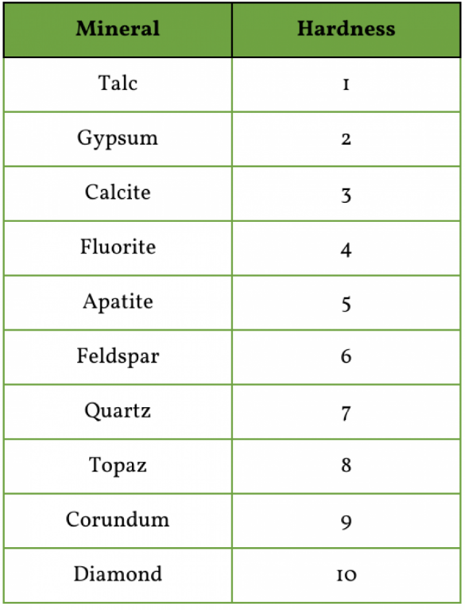

For example, metallic minerals can be hammered and shaped without breaking into pieces, so they are called malleable. Some minerals like mica are elastic: They bend and then bounce back to their original form. Many minerals are brittle, which means they break fairly easily into smaller pieces.

Cleavage planes: planes of weakness in the crystal structure. These cleavage planes produce flat surfaces and angled geometry that are useful for identifying the mineral. The bonds between atoms along the cleavage surfaces are weaker than other atomic bonds in the minerals.

Conchoidal fractur: a fracture that has the appearance of a clamshell.

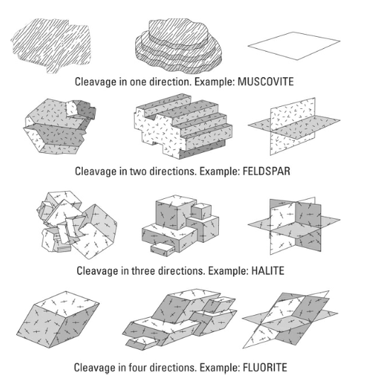

Licking is not a useful way of identifying minerals. In fact, licking unknown minerals may expose you to poisonous metals such as arsenic and lead and is not recommended.

Another way to distinguish calcite from halite: If you spray diluted hydrochloric acid on the mineral and it fizzes and bubbles, you have calcite; if nothing happens, you have halite.

To examine minerals under a microscope, geologists make thin-section slides, which are very thin and polished slices of the rock they want to examine. A thin-section slide is made by attaching a small piece of the rock to a glass slide and grinding down the rock until it is thin enough for light to shine through it. Then the thin-section can be examined under a special geologic microscope, called a petrographic microscope, that shines light through the slide. The petrographic microscope has settings that change the angle of the light shining through the minerals — a process called polarization. composition. The polarized light highlights the internal structure of the crystal, which can indicate the types of minerals in the rock.

Two other properties can be measured in lab environments:

1. Fluorescence- Fluorescent minerals glow when ultraviolet light is shone on them.
2. X-ray diffraction- X-rays are used to reveal distinct patterns of exposed material.

There are eight materials primarily found in rock-forming minerals:

1. Oxygen
2. Silicone
3. Aluminum
4. Iron
5. Calcium
6. Sodium
7. Potassium
8. Magnesium

Silicone and oxygen are the most common elements of Earth’s crust and atoms from these two form the basis for the minerals called silicates. Every silicate mineral begins with a silicon-oxygen tetrahedron of atoms. Multiple tetrahedrons combine to form silicate structures.

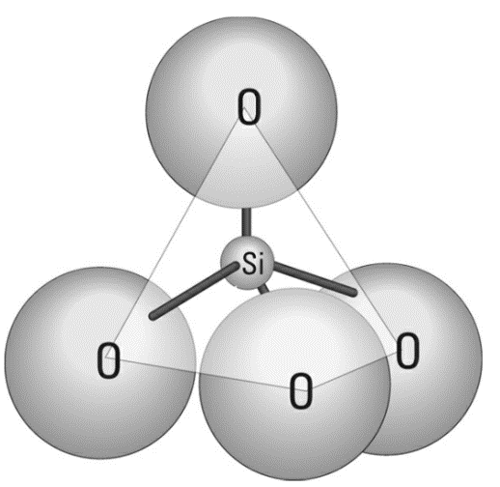

The seven most common silicate groups and structures are listed in the table below.

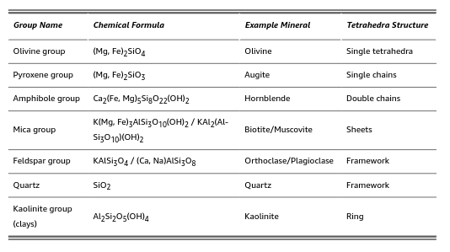

Non-silicate minerals only comprise some 5-8 percent of earth’s crust, most of these are found in sedimentary rocks. Some of the groups of these are:

* Carbonates
* Sulfides and sulfates
* Oxides
* Native elements
* Evaporites

Gemstones are especially valuable. They typically have large crystals that form under very specific conditions such as when molten rock cools very slowly or when rocks are metamorphosized due to extreme heat and pressure.

Rocks can generally be sorted according to composition and texture.

Melting rocks occur under a few conditions: decompression of hot rocks, add volatiles- compounds such as water and carbon dioxide- to lower the melting point of rocks (the process itself is called flux melting), and heat transfers that might come from mantle plumes that are nearby.

Geologists classify magma- and igneous rock- by composition of silica-richness:

* Felsic (rhyolite)-65-75% silica by weight
* Intermediate-52-65% silica by weight
* Mafic-45-52% silica by weight
* Ultramafic-0-45% silica by weight

Source Rock- the term used to describe the original rock type during initial melting.

Crystallizing- the term used when rock solidifies.

Bowen’s reaction series- a reference chart diagramming the sequence of mineralization in igneous rocks.

Partial melting- the term used to describe when only some minerals in rock melt and become added to magma.

As the minerals with the highest melting points are cooled and crystallized, they remove elements from the magma so that only certain elements are left, and these elements can create only certain minerals when they bond together. This process is called fractional crystallization.

Plagioclase- a mineral that forms in igneous rock in all temperatures but has more calcium in its structure when it forms at high temperatures, and more sodium in it when it forms at low temperatures.

Through these processes a magma evolves, or changes, over time. This changing of a magma that produces different igneous rocks is called magmatic differentiation.

As a magma is created, the minerals that melt first are the ones with lower melting points and high silica content (such as quartz and orthoclase), but the magma may not get hot enough for the mafic minerals to melt, so they remain in rock form. This process is called partial melting, which commonly changes magma composition, continuously adding low-temperature-melting-point minerals as it moves upward through the crust. By the time a magma cools, or erupts, partial melting has led it to become more felsic than it was when it first began to melt.

Viscosity is how strongly a fluid resists flowing.

The viscosity of magma plays an important role in building volcanic structures: viscous, felsic melts create explosive stratovolcanoes, whereas mafic melts with low viscosity create flowing shield volcanoes.

If the cooling process occurs underground, the melted rock (which is called magma) cools to form intrusive or plutonic igneous rocks. If the process occurs above ground, such as from a volcanic eruption, the melted rock (which is called lava) cools to form extrusive or volcanic rocks.

Intrusive rocks are formed below the surface, or in the earth, whereas extrusive rocks are formed above the surface, where they have exited the earth.

As a general rule, igneous rocks that form underground have larger minerals than ones that form aboveground, because temperatures cool more slowly underground than at the surface.

The following terms describe the textures associated with igneous rock:

* Phaneritic- Rocks with a phaneritic texture, such as granite, are typically found in the Earth's continental crust and are contrasted with aphanitic rocks, which cool quickly at or near the surface and have small, microscopic crystals. Has large, visible, crystals.
* Aphanitic- Rocks with an aphanitic texture, such as basalt, typically form from volcanic lava flows or eruptions and contrast with phaneritic rocks, which have larger, visible crystals due to slower cooling beneath the surface. The crystals are too small for observation by the naked eye.
* Porphyritic- Rocks with a porphyritic texture show this history of varied cooling rates and can be found in both volcanic and intrusive igneous rock formations. contain a mixture of large crystals, known as phenocrysts, embedded in a finer-grained matrix or groundmass.
* Pegmatite- Pegmatites are important sources of rare minerals and gemstones, such as beryl, tourmaline, and topaz, and can also contain valuable ores of rare elements like lithium and uranium. Known for its exceptionally large and well-formed crystals, including minerals such as quartz, feldspar, and mica.
* Glassy- An igneous rock with crystals that are large enough to see without a microscope. The crystals may be different colors or shapes depending on the composition of the magma and the minerals that form during cooling.
* Vesicular- This is a type of rock that is full of holes. This characteristic is most common in rocks that form from volcanic eruptions.
* Pyroclastic- These are rocks formed by other materials when a volcanic eruption occurs. May look like sedimentary rocks, but are still igneous. If the fragments are small, the rock is called tuff. If the fragments are large, the rock formed is called volcanic breccia.

Lava is referred to in two ways- each based on appearance:

1. Pahoehoe is a wrinkled, ropy-looking lava -and eventually basalt rock- with a smooth surface
2. A’a lava is also composed of basalt but is very different from pahoehoe. Instead of fluidly flowing, forward it looks, and sounds, like an advancing pile of basalt rubble

Extrusive igneous rocks are also called volcanic rocks. That’s because they are created from lava that erupts from volcanoes.

Tephra: refers to fragments of volcanic rock and ash ejected into the air during a volcanic eruption.

Pyroclastic flow: a fast-moving current of hot gas and volcanic materials (such as ash, pumice, and rock fragments) that flows down the sides of a volcano during an explosive eruption.

Magma Chamber-usually about 37 miles below the surface, this is where magma builds up until enough pressure pushed it to the surface.

Pipe- the formation that allows for magma to escape to the surface.

Vent- the external formation where the pipe eject the magma to the surface from the pipe.

Crater- The vent usually opens into the crater, which is a depression created at the top of a volcano from the collapse of surface materials inward when the magma chamber is emptied after an eruption.

Caldera- the large crater formed when the top of an entire volcanic mountain collapses inward.

Dome- A volcanic dome is created when erupting materials cover the vent, creating a dome-shaped feature that grows as gas and magma continue to fill it, until the pressure within forces another eruption.

Cone- the mountain-like structure created over thousands of years as the volcanic lava, gas, ash, and pyroclastic materials spill out onto the surface.

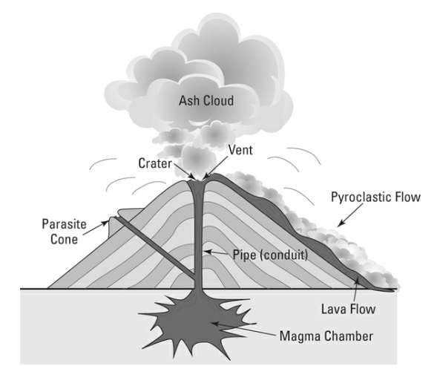

Shield volcanoes usually form from basalt lava that erupts through a vent in the ocean floor (though they can form on continents as well). Shield volcanoes are the largest volcano type created by erupting magma.

Flank eruptions: when other vents open and explode on shield volcanoes.

Stratovolcano, dome volcano, or composite cone. Most of these types of volcanoes are found around the Pacific Ocean, including the recently eruptive Mount St. Helens in Washington State. These are the tall, upright, and peaked volcanoes most people think of as “typical.”

Cinder cones are steep sided, relatively small, cone-shaped volcanic features with relatively large craters at their peaks.

Scoria- glassy, vesicular rocks resulting from gas-filled lava that often originate in cinder cones.

Parasite cones- typically cinder cones, these can often be found on the side of larger volcanoes such as shield and stratovolcanoes.

Plutons are solidified magma underground that form bodies of igneous rock below the surface. The shape of a pluton is described as a somewhat rounded or full shape.

Tabular igneous features form when magma fills cracks in preexisting rock and the resulting rock bodies are flat or linear in shape and are called sills (when they are horizontal) and dikes (when they are vertical).

If the igneous feature cuts through layers of rock, it’s called discordant. If it fills cracks parallel to preexisting sedimentary layers, it’s called concordant.

Dikes are tabular, discordant features created by magma filling narrow cracks or fractures in crustal rock.

Sills are tabular concordant features created when magma fills space horizontally (usually.)

Laccolith: a geological formation that occurs when magma intrudes into the layers of sedimentary rock, but instead of breaking through to the surface (as with a volcano), it pushes the overlying strata upwards, creating a dome or mushroom-shaped body of igneous rock.

Pluton: a body of intrusive igneous rock that solidified from magma beneath the surface of the Earth. Plutons form deep underground when magma cools and crystallizes slowly, allowing large mineral grains to develop.

Batholith: a large mass of intrusive igneous rock that has solidified from magma deep within the Earth's crust. Typically covering an area of about 40 square miles, batholiths are the largest type of plutons. They form when huge volumes of magma cool and crystallize slowly beneath the surface, usually over millions of years. This slow cooling process allows the formation of large, visible crystals.

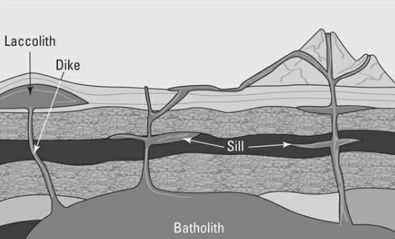

Soils develop from the interaction of sediment with air, water, organic materials (plants and animals), and bedrock. Soils are the sediments that support plant growth by providing mineral nutrients, as well as bringing water and air to the plant roots.

Soils are categorized into zones based on their content. This sequence of zones is called a soil profile. The scientific names of soil types try to describe the bedrock that is being weathered, as well as the climate (tropical and wet, or dry like a desert) and the stage of development the soil is currently in.

When rocks are weathered, they change shape and sometimes composition. Weathering changes the parent rock in one of two ways: by breaking it into smaller particles called sediments or by changing its mineral composition through ion exchange.

Mechanical Weathering: the process of rocks being broken down by weathering processes, without changing the rock’s chemical composition. There are four types:

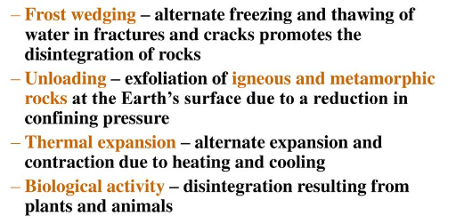

Chemical weathering changes the mineral composition of the rock, removing or exchanging ions from the minerals, or even dissolving them completely. Chemical weathering changes the mineral composition of the rock, removing or exchanging ions from the minerals, or even dissolving them completely. This only affects the surface of the rock. Three types of chemical weathering occur:

1. Dissolution- when water removes ions from a mineral
2. Oxidation- when oxygen bonds with ions
3. Hydrolysis- the exchange of hydrogen or hydroxide ions for a mineral ion

If sediment is transported by gravity or ice, particles of all different sizes will be moved at the same time, resulting in an unsorted or poorly sorted mix of sediments.

If the sediments are transported by water or wind, they are sorted by size. Because wind and water can only carry materials of a certain size and weight, this means a well-sorted mix of sediments occurs.

The distance that sediment travels and its mode of transportation leave visible changes in the particles, sometimes rounding them or scratching them. These changes, along with the size of the particles, give a sedimentary rock its texture and grain size.

Diagenesis- refers to the physical, chemical, and biological changes that sediment undergoes after its initial deposition and during and after its lithification (conversion into rock), excluding surface alteration (weathering) and metamorphism. This process can include compaction, the dissolution and precipitation of minerals, recrystallization, and cementation. Diagenesis can significantly alter the properties of sedimentary rocks, influencing their porosity, permeability, and structural integrity, and is a critical factor in the study of sedimentary geology and the exploration of natural resources like fossil fuels and groundwater.

Lithification is the process that transforms loose sediment into solid rock. It primarily occurs through two mechanisms: compaction and cementation.

Compaction: happens as sediments are buried under more and more layers of sediment. The weight of these layers compresses the sediment grains, reducing the spaces (pores) between them.

Cementation: involves the precipitation of minerals from groundwater moving through the pores between sediment grains. These minerals, often silica, calcite, or iron oxides, effectively "glue" the particles together, creating a solid rock.

Sedimentary rock-forming diagenesis occurs at relatively low temperatures (about 150 to 200 degrees Celsius or less) close to the earth’s surface. When temps are hotter than that, metamorphic rocks are created.

Sedimentary rocks come in two groups:

1. Detrital: particles or fragments that have been transported and deposited by physical processes, usually from the erosion of pre-existing rocks.
2. Chemical: created when minerals are dissolved from existing rock into water and carried to the ocean (or a lake). In a body of water, the minerals re-form into solids, or precipitate, creating particles that settle to the bottom and lithify, becoming a sedimentary rock. These may be composed of organic or inorganic materials.

A basin is anywhere that the surface of the earth is low enough to collect sediments, without an outlet to a lower elevation location.

Cross beds: while most beds are deposited across a flat or horizontal surface, some sedimentary rocks have beds that are at an angle. These result from flowing water or wind depositing the sediments in little piles or dunes.

Metamorphic rocks begin as either igneous, sedimentary, or preexisting metamorphic rocks and undergo a major change, or metamorphosis. The change is caused by high levels of heat and pressure — levels found deep in the earth’s crust, below where sedimentary rocks are formed but not so deep and hot that the rocks are melted into a magma.

Metamorphic rocks occur in 3 different ways:

* Contact with heat
* Burial under rocks or sediments
* Direct pressure and heat from plate collisions

Dynamothermal metamorphism: A common type of metamorphism involving the effects of directed pressures and shearing stress as well as a wide range of confining pressures and temperatures.

Hydrothermal metamorphism: takes place when hot, volatile solutions percolate into and react with the protolith, or the original rock. The heat of the intrusive igneous body and the hot volatile fluids serves to catalyze metamorphic reactions in the host rock. The incident fluids enhance ion mobility in the system and are highly reactive.

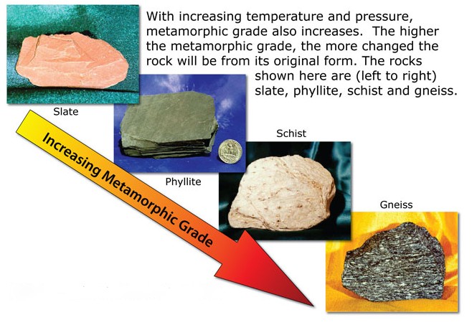

Low-grade metamorphic rocks retain characteristics of the parent rock. High-grade metamorphic rocks look very different from their parent rock.

Metamorphic grades are identified by the minerals in the rock because certain minerals — called index minerals — form only under certain conditions of temperature and pressure.

Indirect pressure pushes on the rocks from all sides, compacting the materials and removing any spaces between crystals or particles. Direct pressure comes from two opposite directions and elongates the minerals into parallel layers.

The elongation of minerals by direct pressure creates a texture specific to metamorphic rocks called foliation.

Metamorphic minerals are created when the atoms rearrange themselves to form completely different minerals from the parent minerals.

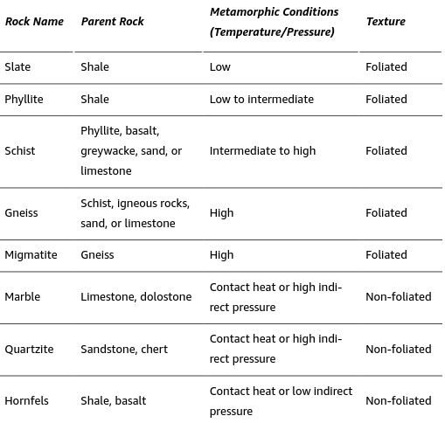

As basalts are exposed to pressure (but still relatively low temperatures), the minerals transform and become foliated. Low pressures create minerals with a green color, so the metamorphic rock is called greenschist well as the green color). Exposed to higher levels of pressure, the green-colored minerals transform into blue-colored minerals, creating blueschist.

Hornfels are metamorphic rocks created through contact metamorphism.

Environments of temperature and pressure are called metamorphic facies, and are commonly talked about in reference to the dominant metamorphic minerals produced under those conditions.

The rock cycle combines all the processes that create, transform, and destroy the different rock types and shows you how the earth materials that compose these rocks are constantly transitioning from one type to the next.

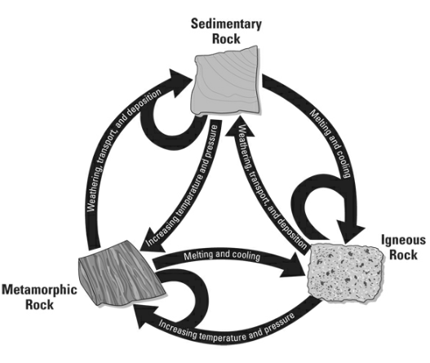

The theory of plate tectonics is the scientific model that explains the movement of the Earth's lithosphere, which is the rigid outermost shell of the planet that includes the crust and the upper portion of the mantle. According to this theory, the lithosphere is divided into several rigid plates that move slowly over the underlying semi-molten asthenosphere.

The continental drift hypothesis was proposed in 1912 by the German meteorologist and geophysicist Alfred Wegener. It stated that the continents are not fixed but have drifted across the Earth's surface over geological time, changing their positions relative to each other.

Continental shelf, the portion of the continent that continues from the coast underwater for a few miles.

Striations: lines cut into the ground as glaciers move across. Looking at these help scientists figure out what direction a glacier is moving in.

After many decades of research, scientists currently accept the idea that movement of heated materials in the mantle of the earth, or mantle convection, plays a large role in driving the continental plates around the surface of the earth.

Rift: a term used to describe a north-south crack on the seafloor along which new seafloor is created.

Bathymetry: using sonar to reveal the high and low points of seabed.

Polar Wandering: The apparent motion of the Earth's magnetic or rotational poles as revealed by palaeomagnetism and other geological techniques. Rather than a motion of the poles relative to the continents—as originally thought—it is now interpreted as a sign of continental drift, as incorporated into the modern theory of plate tectonics.

Magnetic reversal: Earth’s magnetic poles also occasionally switch so that the magnetism recorded from the current geographic North Pole comes from the geographic South Pole instead.

Paleomagnetism is a record of how the earth’s magnetic poles have changed direction over time.

The density of an object is described as the mass per unit of volume. Mass is a measure of the amount of matter in an object (usually measured on a scale similar to weight). Volume is how much space the object fills.

Weight measures the pull of Earth’s gravity on an object, while mass measures the amount of atomic matter in the object.

Continental crust is made of the less dense minerals typical of granite-type rocks.

The density of a floating object relative to the material it floats in determines how much of the object sinks into, or displaces, the liquid.

The position of equilibrium — where the density of the portion of crust sunk into the mantle is equal to the density of the mantle material displaced — is called isostatic equilibrium.

The balance of the solid crust floating in the solidly flowing mantle is called isostasy.

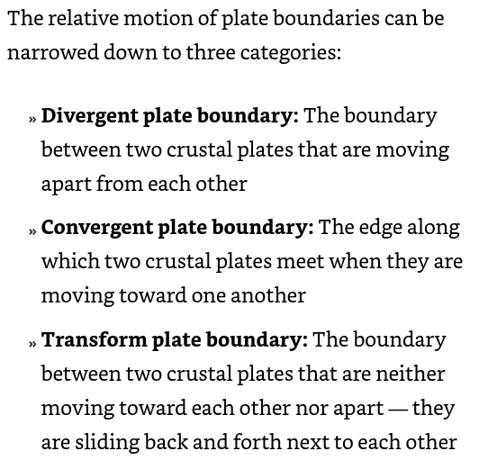

A rift valley is created as the two plates pull apart and the freshly created, cooling rocks between them are stretched until they fault (break) and drop down, creating a valley.

As all the magma from beneath the continental crustal plate breaks through the surface, a chain of volcanoes is created along the surface, parallel to the edge of the subducting oceanic plate. This feature is called a continental volcanic arc.

If the trench and the volcanic arc are close together, the subduction angle is steep. This means the plate reaches the right depth for melting more quickly on its journey downward.

Earthquakes frequently happen on the surface where two plates meet.

When two plates of oceanic crust move toward each other, they create an oceanic convergent boundary. The force of their movement causes the older, colder, and slightly denser plate to be driven beneath the other, down into the mantle rocks below.

As a subducting plate moves downward into the mantle, it pulls the overlying plate downward slightly, creating a deep-sea trench.

A third type of convergent boundary occurs when two plates of continental crust crash into each other. This is called a continental-continental convergent boundary.

Transform boundaries: occur when two plates meet as they move alongside one another. Earthquakes that happen along these boundaries are due to the plates grinding as they slide past one another.

Transform faults: occur along mid-ocean ridge divergent boundaries. These transform boundaries associated with mid-ocean ridges are called fracture zones. As the two oceanic plates move apart, stretching the newly created crustal rocks, some of the material responds to the pull by breaking and slipping to one side or the other.

Compression is what occurs at convergent boundaries where two plates move toward one another and compress or crush the rocks in between them.

Tension Stress: when plates move away from each other at divergent boundaries and the rocks between them are stretched.

Shearing Stress: when plates are moving in opposite directions alongside a divergent boundary and the rocks between them break apart and move with one plate or the other.

Brittle failure or brittle deformation: the term used to describe when an object responds to stress by simply breaking.

Ductile or plastic deformation: a change in the shape of rocks due to high heat and slowly building pressure.

When rocks rocks are compressed by convergent plate movements, they respond plastically by crumpling together or folding. These folded rocks are often described as:

* Monocline: rocks bent only a little
* Anticline: folded rock layers that create an arch
* Syncline: u-shaped folds
* Domes: rounded or oval shaped folds lifted in the center
* Basins: rounded or oval shapes, but they dip downward in the center

Faults are fractures or cracks and fault blocks are the two parts that separate to create a fault. Rocks that move upward and downward are called dip-slip faults. If the rocks move horizontally from one another, they are called a strike-slip fault.

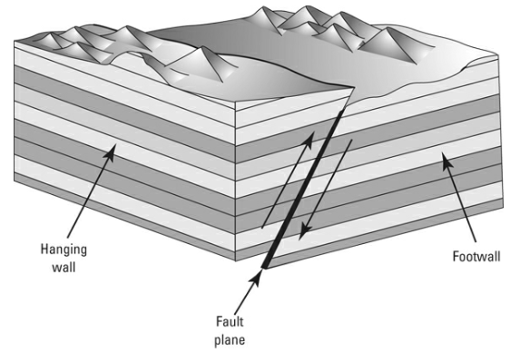

Fractures and faults in rocks where there doesn’t appear to be any movement otherwise are called joints. These are common at the surface of crustal rocks.

Orogenesis: the term used for describing the processes that build mountains.

In regions where the crust is uplifted by hot magma, such as along the mid-ocean divergent boundaries, the tension stress and resulting faults create fault-block mountains.

More common than fault-block mountains are fold-thrust mountains, which occur at convergent boundaries where two plates of continental crust crash together.

Convection: the movement of molten rock (magma) within the Earth's mantle and crust, which can also apply to the movement of heat and material within other parts of the Earth's interior and surface. This process is a key mechanism for heat transfer within the Earth.

Mantle Plume: a relatively narrow, upwelling column of hot and buoyant rock material that rises through the Earth's mantle. This process is thought to be one of the driving mechanisms behind plate tectonics, volcanic hotspots, and various surface geological phenomena.

The term slab-pull describes plate movements driven by the sinking of oceanic crust (the “slab”) into the mantle, pulling the attached crustal plate along behind it. The sinking slab is the downward arm of cooler, dense material in a mantle convection cell. As it sinks, the heated mantle materials deeper in the earth are forced upward, completing the convection cell’s circular motion.

The ridge-push force is driven by gravity. In this model, the heated mantle below a mid-ocean ridge (a plate boundary where new oceanic crust is being created) slightly lifts the crustal plates as it wells up, erupting fresh lava (which cools into basalt, creating a mid-ocean ridge). The elevated ridge then exerts a pushing force outward and downward on each side, away from the rift.

There are three places on the earth where magma-forming conditions exist:

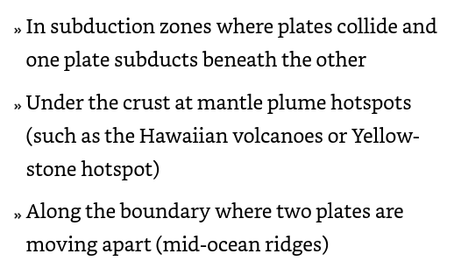

Lava: when melted rock reaches the surface of the earth, it is then considered lava. Before that point it is considered magma.

Partial melting: the incomplete melting of rock where only some minerals are added to melt, while others remain solid rock.

Volcanoes typically occur in two settings: 1) along the edge of a subducting plate as it partially melts, or 2) as a hotspot in the middle of a plate.

Volcanic island arcs are created when two oceanic plates collide and one is subducted under the other. As the subducting crust is melted and the magma rises, it breaks through the crust of the overlying plate, creating a chain of volcanic islands that are roughly parallel to the edge of the subducted plate.

When a continental plate collides with an oceanic plate, the oceanic plate is subducted beneath the continental plate. The magma rises through the overlying continental crust and creates a continental arc: a string of volcanoes along the continental margin, or edge.

Caldera: a large depression formed when a volcano erupts and collapses.

Mid-ocean ridges are mountain ranges on the seafloor. They are created by magma welling up beneath a divergent boundary, where two plates are moving apart. The magma erupts, cools, and forms rocky ridges of basalt.

Earthquake: the elastic rebound of earth’s crust when built-up energy from plate movement is suddenly released. Energy is stored until a slippage occurs, releasing the stored energy suddenly and allowing the rocks to spring back to their previous shape. This response is called elastic rebound.

Aftershock: small earthquakes that occur in the days, months or years in the general area following an earthquake.

Foreshock: earthquakes that precede larger earthquakes in the same location.

Two types of waves travel out from the focus, or origination point, of an earthquake. One type is surface waves, which travel across the surface of the earth just like ripples travel across the surface of a pond when you throw a pebble into it. These waves travel in all directions from the epicenter, which is the location on the surface directly above the earthquake’s focus. Surface waves can move up and down or side to side and are responsible for most of the damage we see from an earthquake. Another type of energy wave, a body wave, travels through the earth’s interior.

P waves are also called compressional waves. They move quickly by compressing rocks, which means the rocks contract and expand as the wave moves through them.

S waves are shear waves. These waves move more slowly and move rocks in an up-and-down motion, very much like holding one end of a piece of rope and wiggling it up and down. Because they move more slowly, S waves arrive after P waves at a seismograph, or earthquake measuring station. S waves can travel only through solid material.

Logarithmic scale: where each unit on the scale is 10 times the magnitude of the previous value.

Mass wasting is the movement of large amounts of earth materials, such as rocks, sediments, and soil, down a slope in response to gravity.

Gravity is constantly pulling materials downslope, but a counteracting force keeps things from always, immediately sliding down.

Friction: the sticking force between two objects.

The angle of repose is the angle of the slope at which sediment and rock are stable and won’t move farther downslope.

Four primary forces are responsible for altering conditions to a point where material may be pulled by gravity:

* Water
* A change in the angle of a slope
* Ground-shaking events
* Vegetation loss

Saturation: when water fills all the space between the particles of sand or rock (called pore space) so that the particles can no longer stick together. When they’re saturated, sediment particles no longer touch each other.

Undercutting: a form of water erosion at the base of a slope creating a steeper angle.

Liquification: a phenomenon that occurs when loosely packed, water-logged sediments temporarily lose their strength and act as a fluid. This usually happens due to the shaking from an earthquake or other sudden change in stress. The process allows the water pressure in between the soil particles to increase, which then reduces the friction holding the particles together. As a result, the soil behaves more like a liquid than a solid.

Landslides: a mass-wasting event.

Slide describes the mass wasting of sediment or rock that moves downslope as one large piece. During a slide, the material stays in contact with the surface as it moves downslope.

A slump is similar to a slide-the materials move as one large piece- but it occurs more slowly than a slide and the materials move along a curved surface.

Flow- mass wasting events where the material moves fluidly.

Earthflows are relatively dry sediments with small grain sizes that move downslope.

Debris flows commonly occur in mountainous areas with steep slopes. They can vary in consistency depending on the mix of water and sediments; some are a thin, muddy fluid, and some are thick like concrete. Very fast debris flows down steep slopes become debris avalanches when the rocks and sediments fall through the air

Lahar: an eruption of ash melts and mixes with glaciers or snow on a volcanic mountain and flows downhill.

Soil creep occurs as small amounts of soil are shifted downslope by the pull of gravity.

Solifluction, or soil flow, occurs when the ground freezes for part of the year. In the summer, the upper layers of soil thaw while the deeper layers stay frozen (this deep-frozen layer is called permafrost).

The hydrologic cycle is the never-ending transformation of water into its different forms.

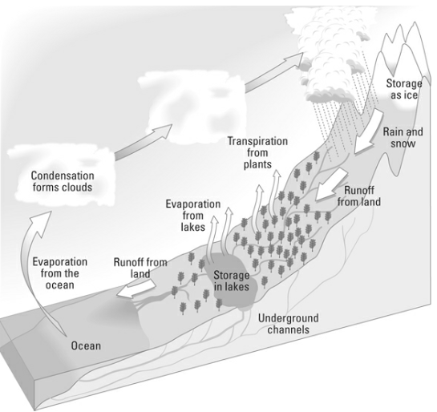

Evaporation: when liquid is heated and the molecules transform from liquid to gas.

Fog: when water molecules in the air coalesce close to the earth’s surface.

Surface runoff: most water that makes its way to the earth’s surface finds itself drawn back to lakes, streams, or oceans.

Groundwater: some of the water that makes its way to the earth’s surface but moves underground.

Snowpacks and ice sheets: water that is frozen and remains as part of snow or becomes locked up in ice sheets for thousands of years.

A basin or watershed is an area of land that supplies water to a stream from rainfall and groundwater. The edges of a watershed are determined by the highest points on the landscape so that a watershed contains all water flowing downhill to a common stream that eventually empties into the ocean.

Some water flows across land in a continuous thin layer, called a sheet flow.

Drainage divide: the highest point of elevation separating two watersheds.

Throughout a watershed, small streams called tributaries flow into larger streams, such as a river or trunk stream that carries the water to its outlet in the nearest ocean, sea, or lake.

Water tends to flow across surfaces in one of two ways:

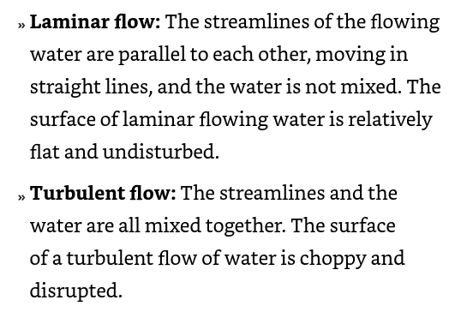

Scientists describe the movement of a stream flow using measurements of how quickly the stream moves and how much water it carries downhill. These characteristics — gradient, velocity, and discharge — are important in understanding how streams carry sediment and create geologic features.

* Gradient: The gradient of a stream is determined by the steepness of the channel, which is defined by the topography of the landscape.
* Velocity: The distance water travels in a given amount of time is a stream’s velocity.
* Discharge: the amount, or volume, of water that passes a given point in a set amount of time.

Suspended flow: sediments that a stream carries in its flow.

Bed flow: sediments too heavy to be carried in the stream’s flow, this is the material that moves along the bottom of the stream.

Saltation: material that bounces along as it is carried by a stream.

Traction: heavy particles that roll along the bottom of a stream.

Dissolved load: the particles that cannot be seen by the naked eye that are moved by a stream; these consist of basic ionic elements from dissolved material.

Capacity: the maximum amount of material a stream can transport. A stream’s capacity is limited by the volume of water (the discharge) — not by the speed of flowing water (its velocity).

Competency: the measure of the largest particle a stream can carry.

Abrasion: when particles carried along the bottom of a stream scouring the channel bed.

Hydraulic lifting: the intense pressure of fast-moving water that removes sediment from the stream bed.

Dissolution: when a stream flows over rocks composed of material that can break down in the water.

Ultimate base level: the limit of how deep a channel’s bed can erode down to.

Temporary base level: a momentary point when a bed cannot erode deeper, but it is still above its ultimate base level. Often, a particular material prevents the channel from deepening, but once it is removed, the channel can achieve its ultimate base level.

Deposition: the term used to describe material that builds up when a stream can no longer transport it.

If a stream were at equilibrium, the stream would have the exact amount of energy needed to transport all the sediment that is supplied to it. This is also called a graded stream.

Drainage patterns: the patterns etched into a landscape due to running water. There are four common patterns:

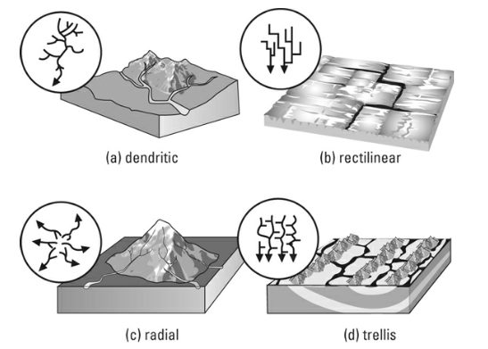

Stream channel patterns: used to describe the plan view of a reach of river as seen from an airplane, and includes meandering, braiding, or relatively straight channels. There are four types:

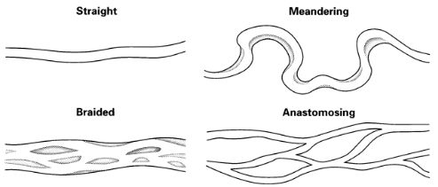

Oxbow lakes are created because of the way the stream’s flow speed (velocity) changes as it twists and bends around the curves:

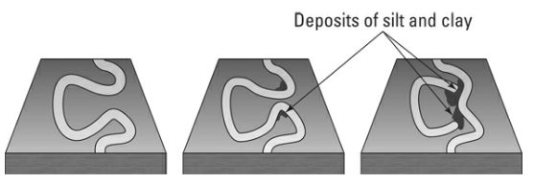

Within any stream the velocity is greater on the outside edge of a turn, which means the outside edge picks up or erodes more sediments. Velocity is slower on the inside edge of the curve, leaving behind or depositing sediments. These deposited sediments create a point bar.

Alluvium: any earth material left behind by a stream, regardless of size or shape.

Floodplain: the area around a stream or waterway that can be flooded when water flows out of its channel.

Levee: created when the largest particles are deposited from the flooding stream.

Backswamp: composed of the smaller sediment particles such as clay and silt that are carried farther along as the floodwater slows down.

Alluvial fan: a stream flowing through a mountainous region suddenly flows out onto the relatively flat surface of a valley floor. The speed of the streamflow slows down very quickly and deposits a large amount of sediment.

Delta: a landform shaped like a triangle, created by the deposition of sediment that is carried by a river and enters slower-moving or stagnant water. This occurs at a river mouth, when it enters an ocean, sea, estuary, lake, reservoir, or another river that cannot carry away the supplied sediment.

Groundwater doesn’t flow as quickly as surface streams- because it has to move through sediments and rocks- but it does flow.

The movement of rainwater through the soil layers into sediment and rock layers below the earth’s surface is called infiltration. Three factors can increase filtration:

1. Increased space between particles allowing more water to move through it
2. Decreasing ground slope allowing rainfall to sink in
3. Lowered rainfall intensity allowing for better chances for it to be absorbed

Porosity: the measure of space between particles, expressed as a percentage of total volume.

Permeability: how easily water can move through rock or sediment.

Groundwater flow is also affected by pressure from the earth materials piled above it. The combination of gravity and pressure is called the groundwater’s potential. The difference in groundwater potential across a measure of distance -like a mile or kilometer- is called the hydraulic gradient, which indicates the direction of groundwater flow.

The boundary between the zone of aeration and the zone of saturation is called the water table.

Zone of aeration: area of an unconfined aquifer above the water table where the pore spaces among soil particles and rock formations are filled with air.

Zone of saturation: the ground below a water table.

Capillary or wicking action: the process of a liquid flowing in a narrow space in opposition to or at least without the assistance of any external forces like gravity. This is possible because water molecules are drawn toward each other. This happens in an area just above the water table in an area called the capillary fringe.

Springs are locations where groundwater flows out onto the surface. You often find springs on slopes where the change in elevation of the ground surface intersects the elevation of the water table, allowing groundwater to flow to the surface out of the hillside.

Aquifer: any rock or sediment where fresh water is stored.

Unconfined aquifers: means that the rocks and sediment above the stored water are permeable.

Confined aquifers, or artesian aquifers, are layers of rock or sediment filled with water that have an impermeable layer above them.

A geyser is like an artesian spring: Groundwater flows up to the surface, against the pull of gravity. But a geyser is not forced upward due to pressure and the impermeability of surrounding rock layers, but because it is very hot.

Soluble rocks: rock and sediment that is made of minerals easily dissolved or carried away by water, leaving holes in rocks.

Karst: an area of the earth’s crust that has been eroded by groundwater and has large pockets.

Dripstones: the formations found inside caves, formed as water drips through rock overhead. There are two kinds:

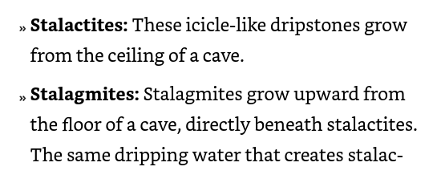

Sinkhole: in areas with karst, these may occur due to the abundance of caves below the surface.

Glaciers: massive amounts of ice requiring cold temperatures and high amounts of snowfall. Most often these conditions can be found at high latitudes- areas close to the north or south pole- or close to the equator at high altitudes. Valley or alpine glaciers are the most common glaciers and the smallest.

Glaciation: when ice covers a significant portion of continents and oceans.

Ice sheets are not contained by valleys and flow out in all directions from a central point. When ice sheets flow out over the sea, they form ice shelves.

Ice caps cover areas of a continent, such as portions of Iceland, on a much smaller scale than ice sheets. Like ice sheets, ice caps flow out in all directions.

Outlet glaciers: when an ice sheet or ice cap has valley glaciers flowing from its main body into surrounding valleys.

Piedmont glacier: a glacier formed by convergence of the ends of valley glaciers at the base of mountains.

Firn: compaction of snow that occurs over time, reducing airspace and increasing tightness to the point that this type of snow resists melting in the summer.

Glacial budget: the term used to describe whether a glacier is growing or shrinking.

Ablation: when glacial ice is subtracted due to decreased snowfall and increasing temperatures.

Zone of accumulation: a higher elevation where more snow falls each winter than melts in the summer.

Zone of ablation: lower elevations where all the snow that has fallen in a year will melt in warmer temperatures.

The line of equilibrium or snowline is where the zone of ablation and zone of accumulation meet.

When a glacier’s annual accumulation of ice is more than its ablation, or wastage, for a few consecutive years, it has a positive budget and is increasing in size or advancing.

Terminus: the edge of a glacier.

When a glacier experiences more wastage, or ablation, than accumulation — the glacier has a negative budget.

Glacial retreat: the term used to describe when a glacier’s terminus moves upward as a byproduct of melt off.

The rate of plastic flow in a glacier increases as the temperature of the ice approaches the melting point — the warmer the ice, the more quickly it flows.

Basal sliding: glacial melting that occurs at the point where a glacier touches earth’s surface, due to a bit of heat occurring at that point. This melt-off helps the glacier slide.

Surge: when a glacial flow increases greatly for a short period of time, such as 100 feet per day for several months. Scientists think a surge occurs when the water underneath the glacier builds up and leads to a sudden increase in basal sliding.

Plucking (or quarrying) occurs when ice moves across a surface of bedrock and lifts large blocks of rock up into the ice flow.

When a glacier carries rocks and sediments, some of these materials scrape against the surface of bedrock that it flows over. This scraping is called abrasion.

Glacial striations: scratching of a surface as a glacier moves along it. This can produce a polished appearance in bedrock.

Rock flour: a fine, powder-like, sediment produced when ice scratches and grinds against bedrock.

Glacial trough: the u-shaped valley left behind after a glacier has moved through.

Glacial troughs that reach the sea at the edge of a continent are filled in as small, steep-sided bays, or fjords, when the glacial ice no longer fills the valley.

As small tributary glaciers feed into a main or trunk glacier, the trunk glacier, being larger, will cut its valley more deeply than the surrounding tributary glacial valleys. When the glaciers retreat, the tributary glaciers leave hanging valleys along the path of the trunk valley.

Paternoster lakes: These lakes are created in the glacial trough as ice plucks pieces of bedrock from the valley floor, leaving a string of holes that are later filled by water and become lakes.

Cirques are the circular- or half-circle shape- depressions near a mountaintop where alpine glaciers begin.

When multiple glaciers exist on a mountain, two cirques (or two moraines) may create a sharp, steep ridge of erosion-resistant rock between them. This linear ridge is called an arête.

Horns are created by multiple cirques on a mountain. In this case, three or more cirques create a sharply pointed peak in the landscape by eroding rocks and sediments from many sides of a mountaintop.

A roche moutonnée is created when ice smooths and polishes the uphill side of a bedrock hill, while plucking and removing rocks from the downhill side as it flows across.

Glacial lakes are named paternoster lakes because they look like a chain of rosary beads in a valley.

Glacial drift describes any sediment left behind by melting glacial ice. Glacial drift is the result of movement and deposition by ice but not by floating icebergs; these sediments were deposited by ice sheets and glaciers.

Glacial till is any rock or sediment that has been carried and left directly by glacial ice. Because ice can carry rocks and sediment of various sizes without separating them by size, till deposits are often a mix of different sized rocks and sediment.

Glacial till often piles up alongside the edges of a glacier or at the end of one. These piles of poorly sorted sediments are called moraines. Terminal moraines or end moraines occur at the end of a glacier as it recedes, melting and leaving the till behind. Lateral moraines occur along the edges of a glacier. Medial moraines occur in between two glaciers.

When a large glacier or ice sheet advances over preexisting moraines (from the earlier advance and retreat of glaciers), the original till deposit will be reshaped by erosion into rounded, elongated hills called drumlins.

Drumlins created by ice sheets often occur in groups, or drumlin fields, with hundreds of drumlins scattered across the landscape.

Stratified glacial deposits occur when sediment is removed from the glacial ice by meltwater in the form of streams.

In a mountain valley, deposits are often left by braided streams, the deposits left by these streams are called a valley train. When these deposits are left beyond the edge of a melting ice sheet, they create an outwash plain.

A kettle lake is a type of lake that forms when a block of ice from a glacier is buried in glacial debris and then melts, leaving behind a hole that fills with water. As glaciers retreat, they often leave behind chunks of ice in their till or moraine. These chunks of ice can be partially to completely buried under the sediment. When the ice blocks melt, they create depressions in the landscape. If these depressions are deep enough and in the right conditions, they can fill with water, forming a lake.

Eskers and kames are deposits of sand and gravel left by meltwater flowing in, under, or over the ice of a melting glacier. Eskers are long, snake-like ridges of sand and gravel. Kames are steep-sided hills created by the deposition of sand and gravel in depressions on top of melting ice.

Glacial erratics are large boulders carried far from their place of origination by glaciers and left there when the glacier moves on.

Glacial geomorphologists study the landscape shaped by glaciers and ice sheets to understand how much ice covered the continents and when it retreated or melted. Periods in the past when ice covered much of the continents are called ice ages.

Scientists have determined two primary causes of ice age cycling: changes in the position of the continents on the earth’s surface and changes in the earth’s position relative to the sun.

The presence of ice on the land and ocean surface at the poles becomes a mirror that reflects the sun’s heat instead of absorbing it. This reflection, or albedo, leads the earth’s entire climate to become colder and intensifies the cold of winter, creating larger, more extensive sheets of ice.

The other cause of ice age cycles is the position of the earth relative to the sun. These cycles are described as eccentricity, obliquity, and precession. Together they are named Milankovitch cycles after the astronomer Milutin Milanković, who first calculated them about a hundred years ago.

Eccentricity: As the earth orbits the sun, it does not always follow a perfectly circular route. Sometimes its route is more oval shaped, meaning that at the farthest reaches of its orbital loop it is farthest from the sun.

Obliquity: As the earth rotates on its axis and moves around the sun, it is also slightly tilted. The degree of tilt shifts about 2 degrees over a period of 40,000 years. When the earth is tilted the most, the northern hemisphere of the planet is tilted farthest away from the sun.

Precession: Along with tilting, the earth also wobbles on its axis. The axis (at the North Pole) points in different directions in the sky over a period of about 26,000 years.

The result of all that ice pushing down on parts of the continent changes the relative sea level along the coasts. The movement in response to the removal of the weight of the ice sheet is called isostatic rebound.

In regions that lack water, such as deserts, wind is the most important geologic force; it creates geologic features by removing rock particles (erosion) and adding new sediments (deposition). The term aeolian (sometimes spelled eolian) describes the processes and features of wind.

Unlike what you may see in movies and television, the arid regions of Earth are not all hot, sunny, sand-covered expanses. On the contrary, only a few arid regions meet that description, such as the Arabian Desert of Saudi Arabia. Other arid landscapes occur in cold climates (such as Antarctica), along coastlines (such as the Atacama Desert of South America’s west coast), and in mountainous continental interiors (such as the Himalayas of Asia and the Rocky Mountains of North America).

Like water, wind flows in two different manners:

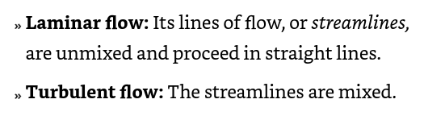

Creep: when particles are too large and heavy to be carried by wind, but can be pushed along the ground by wind.

Deflation: refers to the process of wind erosion that removes loose particles of sand, dust, and soil from the surface of the ground. This process is most prevalent in arid and semi-arid environments, where vegetation cover is sparse, and the soil is not tightly bound by moisture.

Suspended load: when particles are completely carried away from the surface and carried with the flow of the wind.

Wind deflates a surface, lowering it as sediments are removed. This process of wind erosion is called deflation.

Blowout: small, shallow areas, sometimes only a few meters wide and less than a meter deep, where deflation has occurred. Deflation basins are the term used for much larger areas of blowout.

Wind abrasion: the blasting of sediments against another object by wind propulsion.

Ventifacts: a rock that has been shaped, polished, or faceted by the abrasive action of wind-driven sand or ice crystals. These natural sculptures are found in desert environments or areas with minimal vegetation and strong, persistent winds.

Dunes: a mound, hill, or ridge of sand or other loose sediment that is formed by the wind, and sometimes by water flow, in various environments including deserts, beaches, and along riverbanks. Dunes are dynamic landforms that are shaped by the movement of wind or water which transports and deposits sand in new locations, often creating characteristic shapes and patterns.

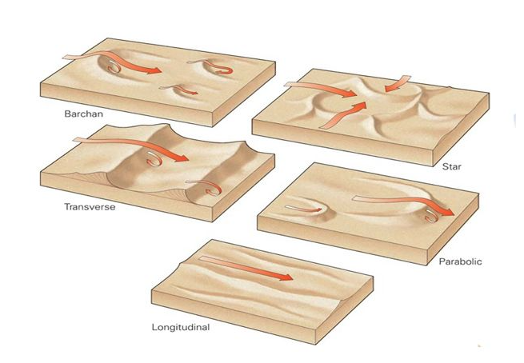

Loess: a fine-grained, wind-blown sediment composed predominantly of silt-sized particles, mixed with a smaller amount of clay and sand. It is known for its pale yellow or buff color, and its ability to maintain a vertical cliff face because it is loosely cemented by calcium carbonate. Loess deposits are usually very fertile and thus are important for agricultural activities.

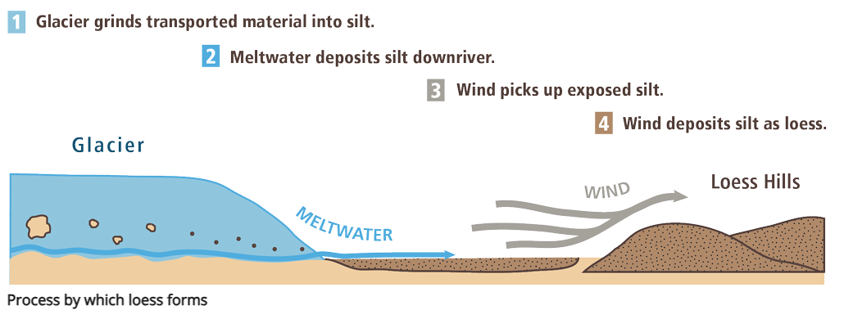

Barchan dunes are created when the sand supply is limited and the land surface is flat. They are crescent-shaped, like a half moon, with two points or horns pointed downwind, or in the direction the wind is blowing.

Parabolic dunes appear similar to barchan dunes in shape, except the horns of their crescent shape point upwind, in the direction the wind flows from, instead of downwind.

Desertification is the process of changing productive farm or grazing land into barren desert. The loss of useful farmland to desertification is one of the major threats of climate change. The most common cause of desertification is allowing animals to overgraze or eat all the vegetation in a confined area.

Loess sediments possess unique qualities that make them desirable as farmland:

* Loess particles have not been altered by chemical weathering. This means these elements are available in the loess deposits as mineral nutrients to support vegetation.
* Loess particles are windblown and angular. Because of the angular shapes, when the particles are deposited they don’t pack together very tightly, which means there is space between them for water to accumulate. The result is that water is available as moisture for plant roots.

Desert pavement is a thin layer of pebbles and rocks across the land surface. For a long time, geologists thought desert pavement was the result of erosion — the result of wind removing smaller particles from the surface, leaving behind a layer of larger pebbles and gravel. This layer left behind is called a lag deposit or lag feature.

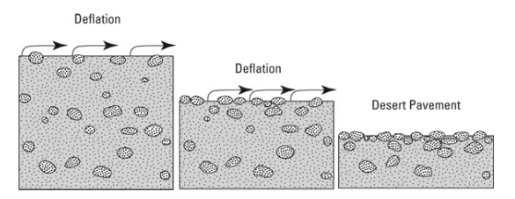

Waves are created when wind blows across the surface of water, pushing the water up into crests and low troughs between crests. Wave features include:

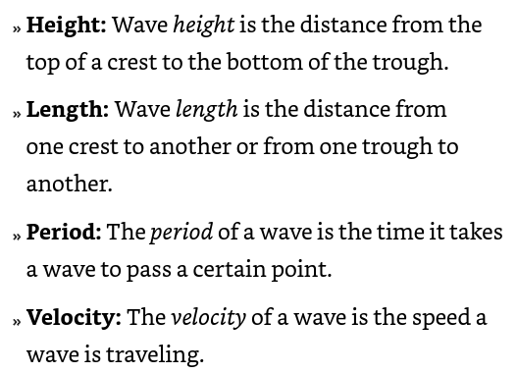

The characters that determine wave features include:

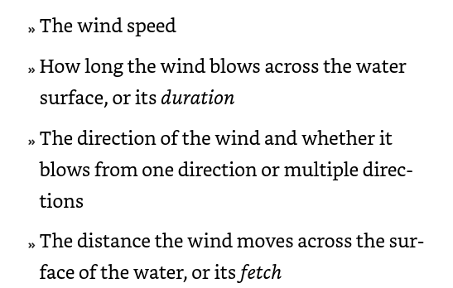

The force of the blowing wind causes the water to move in a rolling pattern. This pattern is called oscillatory motion. In the middle of the ocean, when the water moves in oscillatory motion, the water itself moves only a small distance while the energy of the wave keeps moving.

When oscillatory waves move into shallow water, such as near the shore, the below-surface oscillatory wave motion is interrupted by hitting the bottom. In response to this friction, the wave slows down. Other incoming waves catch up to it, and they get bunched together in a traffic jam of waves approaching the shore. The combined water of the multiple waves builds a higher wave that is eventually too tall to support itself and collapses, or breaks, as it hits the shore.

Unlike the oscillatory waves of the open sea, translatory waves move the water some distance up onto the beach. The water moving up onto the beach is called swash, and the water that moves back toward the sea is called backwash.

Tides move ocean water toward and away from land in response to the pull of the moon’s gravity.

The high tides occur in the places that are closest to and farthest from the moon, where the bulging of water is the greatest.

Low tide is when the water is moving away from the land, and high tide is when it moves toward land. The flow of water with the tides creates tidal currents. When the tides are moving from low tide to high tide, the tide is “coming in” and the tidal current is called a flood current. When the tide is “going out,” or switching to low tide, the movement of water away from the shore is called an ebb current. The areas along the shore that are covered and uncovered by the cycle of tidal currents are called tidal flats.

When waves hit the beach at an angle, their motion creates longshore currents.

If you have ever swum in the ocean and noticed that after a while you have moved along the beach away from where you left your towel, you have been moving with the longshore currents. This movement you experience is called shoredrift.

Another type of ocean current is a rip current (aka undertow). Rip currents occur when wave energy hits the shore straight on, and the returning water washes straight out to deeper water rather than being moved along the shore.

Where waves meet rocky, steep shores they carve away sediments, creating a wave-cut cliff. Materials are removed from the cliff by the force of water, leaving behind a flat area below the cliff called the wave-cut platform. A rocky coastline being eroded will often have cliffs that extend out into the water, called headlands. These headlands are made of rock or sediment that resist erosion by the waves.

Some interesting geography carved by coastal currents include:

* Sea caves: created as the waves remove easily eroded sediments and rock from the cliff, carving out a cave
* Sea arch: When two caves being carved out near each other connect (often on opposite sides of a headland), they form a sea arch
* Sea stack: After enough time, the top of the sea arch will weaken and fall, leaving tall, freestanding sea stack features.

Depositional features of a shoreline depend largely on the amount of sediments available to be transported and deposited, or the sediment budget.

Depositional features created by shoreline processes include:

* Spits
* Baymouth bars
* Tombolos

Primary coastline: is a type of coastline that has been formed primarily by the processes that have occurred at the boundary between the land and the sea, rather than by the action of marine processes which modify the existing coastline.

Secondary coastline: A secondary coastline is formed and shaped mainly by marine processes such as erosion, sediment deposition, and the action of waves and currents. These coastlines evolve from existing landforms that are modified by the sea, making features like beaches, spits, and barrier islands typical of secondary coastlines.

Tsunami is a series of very large waves that travel across the ocean following an undersea geologic event such as an earthquake, volcanic eruption, or landslide. Most often tsunamis are the result of undersea earthquakes.

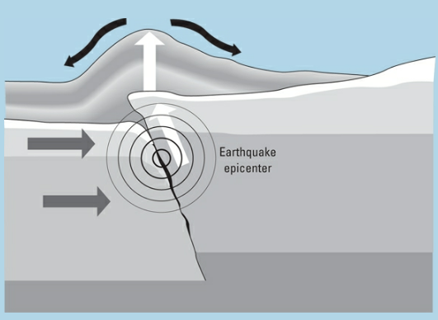

Runup: the term used to describe the height of water above sea level.

Organizing rock layers into the order of their formation is the first step in constructing a geologic history. When the events are in the proper order, the story in the rock layers can be read.

Relative dating does not provide numerical ages or dates for events. Relative dating techniques describe only when events happen in relation to other events.

Stratigraphers compile information from rock layers all around the world and compare that information in order to understand the sequence of rock layer formation and details about the history of Earth’s surface.

Absolute dating: This method involves the use of radiometric dating techniques, which measure the decay of radioactive isotopes within the rocks. Isotopes are atoms of the same element with different numbers of neutrons, and some are unstable (radioactive), naturally decaying into other elements over time at a consistent rate.

Scientists describe rock layers by units. There are several different unit types:

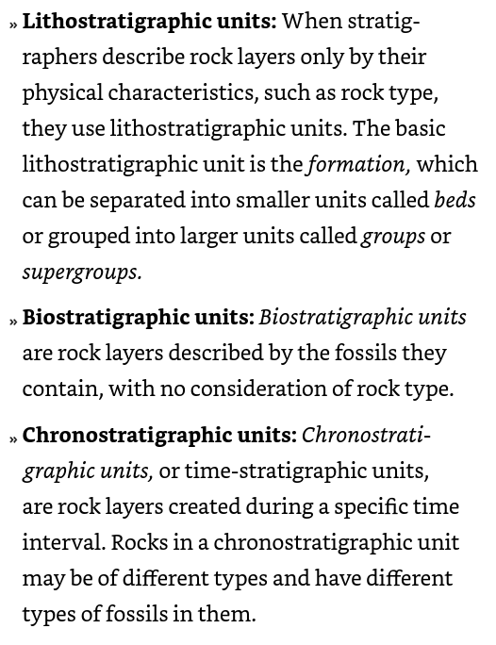

Four principles are applied toward stratigraphy:

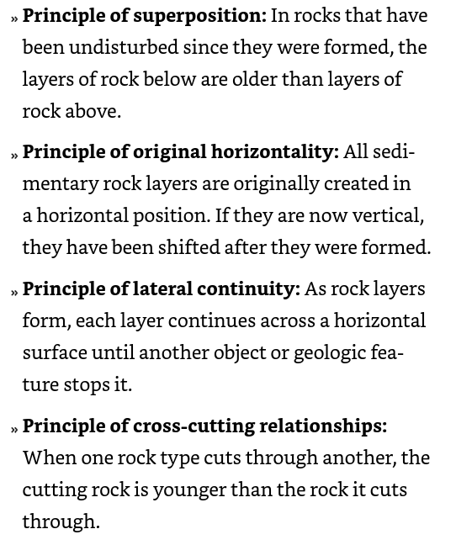

The principle of fossil succession is the idea that different layers of rock contain distinct fossils based on the age of those layers. This means that as you move through layers of sedimentary rock, from oldest to youngest, you'll find different types of fossils in a consistent order.

The principle of inclusions states that any rock fragments (inclusions) found within another rock must be older than the rock in which they are enclosed. Essentially, for a rock to contain fragments of another rock, those fragments must have existed before the surrounding rock was formed. This principle helps geologists determine the relative ages of rocks in complex geological structures.

When rock layers are conformable, it means there's no evidence of erosion, significant time gaps, or disturbances between them. Each layer follows the next in a sequence that reflects a steady accumulation of sediments, indicating a continuous and undisturbed depositional environment over the period of their formation.

An unconformity occurs when rock layers have been eroded, moved, or otherwise changed, and then more rock layers are added above.

An angular unconformity is a geological feature where layers of rock are tilted and then eroded, followed by the deposition of new, horizontally layered sediments on top. This creates a visible angle between the older, tilted layers and the newer, flat layers above them. Angular unconformities demonstrate a period of geological upheaval where the original rocks were tilted (often by tectonic activity) and eroded before a calm period returned, allowing new sediments to deposit in a horizontal layer. This structure records a gap in the geological timeline, showing a sequence of deposition, disturbance, erosion, and then renewed deposition.

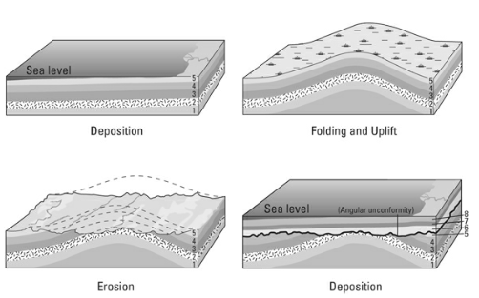

A disconformity is a type of unconformity in the geological record where layers of sedimentary rock are separated by a surface of erosion (or non-deposition) but, unlike an angular unconformity, the rock layers above and below the unconformity are parallel to each other. This indicates that the erosion or non-deposition event did not significantly disturb the angular position of the strata. Disconformities can be hard to detect because the sediment layers appear continuous and orderly, despite the significant time gap that the erosion surface represents between them. This gap can signify periods of erosion where no sediment was deposited or periods when erosion removed previously deposited layers before sedimentation resumed.

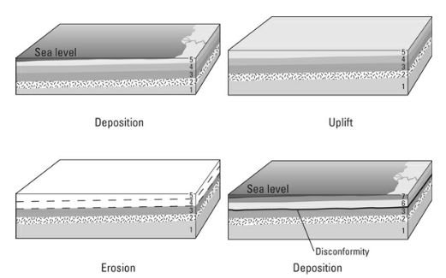

A nonconformity in geology is a type of unconformity where sedimentary rocks are deposited directly on top of older, eroded igneous or metamorphic rocks. This indicates a significant gap in the geological record, where there was a transition from the formation of igneous or metamorphic rocks to a period of erosion and then the deposition of sedimentary layers. Nonconformities can mark major changes in geological conditions and are important for understanding the Earth's history, showing periods where there was enough erosion to expose the older, harder rock before sedimentary rock started to accumulate on top.

An absolute date in geology is a specific point in time used to determine the age of a rock, fossil, or geological event, typically expressed in years. It's obtained through radiometric dating methods, which measure the decay of radioactive isotopes in materials, providing a precise age rather than a relative one (which places events in order without specifying how long ago they occurred).

The most common method used to determine the numeric age of rocks is called radiometric dating. This method measures the decay, or atomic changes, in certain atoms.

Some isotopes are unstable, or radioactive, which means changes automatically occur within the nucleus that transform the isotope into a completely different element by changing its atomic number.

If the number of neutrons in an atom of an element changes, the atomic mass number changes, which creates an isotope. If the number of protons in an atom change, both the atomic number and the atomic mass number change, and you have a completely different element.

Isotopes decay in three ways:

1. Alpha Decay: when an unstable atom releases an alpha particle (2 protons and 2 neutrons), turning into a lighter element.
2. Beta Decay: when an unstable atom emits a beta particle (electron or positron), changing its atomic number.
3. Beta Capture: when an atom absorbs an electron, changing a proton to a neutron and reducing its atomic number.

Radioactive isotopes begin as one element and, through decay, become another. The original element is called the parent isotope, and the resulting element is called the daughter isotope. Comparing the number of parent and daughter isotopes and knowing how long it takes for each radioactive element to decay is what provides a numerical age for rocks.

A half-life is the amount of time it takes for half the parent isotope atoms to decay into daughter isotope atoms.

Relative dating and stratigraphy are used to estimate how old the rocks are, the best radioactive isotope system is selected based on the minerals of the rock. Even so, using more than one isotope pair measurement can provide the best result.

When two isotopes are measured and prove to be in agreement, or reasonably close, this is called concordance. Discordance is the term used to describe the opposite.

Fission track dating measures the age of rocks or artifacts by counting the tiny damage marks left by uranium decay. It's useful for finding out how old things are, from about 100,000 years up to several billion years.

Dendrochronology is the scientific method of dating tree rings to the exact year they were formed to analyze historical and environmental events.

Radiocarbon dating measures the age of organic materials by analyzing their carbon-14 content, effective up to about 50,000 years. This works by comparing the amount of carbon-14, a radioactive isotope, to the amount of carbon-12 in a sample. Since carbon-14 decays over time while carbon-12 remains constant, the ratio between them indicates how long it's been since the material stopped exchanging carbon with the environment, typically when it died. This gives us the age of the sample.

Bracketing means that the geologist takes a sample of dateable material (for example, a mineral from a metamorphic or igneous rock) from immediately above and immediately below the rock layer (or rock) she wants an age for.

The geologic time scale is a system of chronological dating that relates geological strata to time, used by geologists, paleontologists, and other Earth scientists to describe the timing and relationships of events in geologic history. It's divided into several major categories, from largest to smallest:

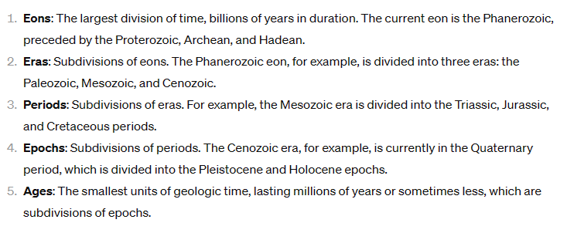

A scientific theory is a well-substantiated explanation of some aspect of the natural world, based on a body of facts that have been repeatedly confirmed through observation and experimentation. Unlike hypotheses, theories are broader in scope, supported by a large and growing body of evidence, and can provide predictions about future observations.

The theory of evolution is a scientific explanation for the diversity of life on Earth. It states that all living beings have descended from a common ancestor over time through a process called natural selection, where organisms with traits better suited to their environment are more likely to survive and reproduce. This leads to changes in populations over generations, resulting in the variety of life forms observed today. Remember: the theory of evolution explains the mechanism of how biological change occurs, not why it occurred.

Traits are the observable or measurable characteristics of an organism, such as eye color, hair color, height, or the presence or absence of certain physical or behavioral attributes. These traits are determined by the genetic information, or genes, that are inherited from the parents.

Traits can be classified as either dominant or recessive. A dominant trait is one that is expressed in the offspring even if the individual has only one copy of the gene for that trait. On the other hand, a recessive trait is only expressed in the offspring if the individual has two copies of the gene for that trait.

The basic idea of the inheritance of acquired traits is that if an organism develops a new trait or characteristic during its lifetime, those acquired traits can be passed on to the organism's offspring. Today, this is largely believed to be incorrect.

Artificial selection is a process in which humans intentionally select and breed organisms with desired traits to produce offspring with those preferred characteristics.

Natural selection is a fundamental process in the theory of evolution that explains how living organisms change and adapt over time through the selective reproduction of certain traits.

Scientists determined that within their cells, all organisms have molecules of DNA (deoxyribonucleic acid) organized as chromosomes. Each cell in an organism’s body has two sets of the chromosomes needed to create that organism, with one exception: the sex cells. The sex cells, sperm and egg cells, each have only one set of chromosomes.

Genetic mutation refers to a change or alteration in the DNA sequence of a gene or chromosome. Mutations can have a wide range of effects, from having no observable impact to causing significant changes in the characteristics and functioning of an organism. Mutagens are chemicals that alter a chromosome.

Beneficial mutations increase the chance of an organism’s survival. Neutral mutations occur in an organism, but have no impact on an organism’s survival.

Speciation: the development of new species from existing ones through mutation and natural selection.

Generally, evolution through natural selection goes like this:

1. Genes mutate randomly.
2. Physical traits are expressed.
3. Individuals are selected.
4. Populations reproduce and evolve.

A species is a group of living organisms that can interbreed and produce fertile offspring, and are reproductively isolated from other such groups.

There are two explanations for how species develop through natural selection:

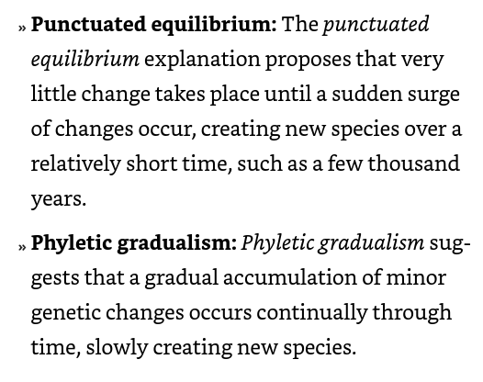

Neo-Darwinian evolution states that evolution occurs through the gradual, step-by-step changes in the genetic makeup of a population over successive generations. Beneficial genetic variations are maintained and spread through natural selection, while less advantageous traits are weeded out.

Fossils are formed when living things are buried and preserved in sedimentary rock, ice, or amber. The most common types of fossils include:

* Body fossils - These are the actual remains of the organism, such as bones, shells, teeth, leaves, or even entire bodies.
* Trace fossils - These are the preserved evidence of an organism's activity, such as footprints, burrows, or fossilized feces.

Body fossils: preserved body parts.

Unaltered body fossils: preserved, unaltered, body parts- usually due to mummification or freezing.

Altered body fossils: remains that are changed through chemical processes, preserving body shape but not original composition.

Replacement fossilization: a type of fossilization process where the original organic material in a living organism is slowly replaced by mineral deposits over time. This happens when the remains of a plant or animal are buried and exposed to mineral-rich groundwater or other solutions.

Permineralization: occurs when minerals seep into the open spaces but leave some of the organic material in place.

Carbonization: when some organisms can be preserved as carbon film that retains the shape of the organism.

Mold or cast: when a dead organism is buried in sediment and the tissue decays, preserving an outline or detail of the body.

Trace fossils: unlike other fossils that may preserve tissue or body details, these fossils only preserve some sort of evidence that the organism lived. This can be in the form or tracks, footprints, or coprolites- preserved droppings.

Bias can occur in the fossil record when fossils are not left behind to indicate the existence of an organism, so we either don’t know they existed, or fail to understand much about them.

Cladistics is a method of biological classification that groups organisms based on shared derived characteristics, called synapomorphies. The key principles of cladistics are:

* Common Ancestry: Organisms are grouped together based on the idea that they share a common evolutionary ancestor.
* Synapomorphies: Cladistic analysis focuses on identifying shared derived characteristics that are unique to a group of organisms. These shared derived traits are called synapomorphies.
* Hierarchical Classification: Cladistic trees, called cladograms, show the hierarchical relationships between organisms based on their shared synapomorphies. Closely related organisms will be grouped together in nested clades.
* Parsimony: Cladistic analysis aims to construct the simplest evolutionary tree, or cladogram, that explains the distribution of observed characteristics among the organisms being studied.

By examining the branching pattern and placement of taxa in a cladogram, scientists can infer the phylogenetic relationships and evolutionary history of the organisms. This information is crucial for understanding the patterns and processes of biological evolution.

Cladograms are constructed through cladistic analysis, which compares the shared derived characteristics of the organisms being studied. The resulting cladogram represents the most parsimonious, or simplest, explanation of how the lineages are related.

The chart below outlines some of the basic information about each age.

In the geological context, differentiation refers to the process by which an initially homogeneous magma, or molten rock, separates into distinct mineral assemblages or layers with different chemical compositions. This separation occurs due to the differences in the physical and chemical properties of the minerals present in the magma, such as their melting points, densities, and the way they interact with each other.

Supercontinent: a single landmass consisting of at least two preexisting landmasses.

Prokaryotes were (and still are) small cells with no internal organs that reproduced asexually. Modern-day prokaryotes include bacteria.

Eukaryotes a type of organism that has a distinct, membrane-bound nucleus and other membrane-bound organelles within its cells. Eukaryotes are one of the three domains of life, the other two being bacteria (prokaryotes) and archaea.

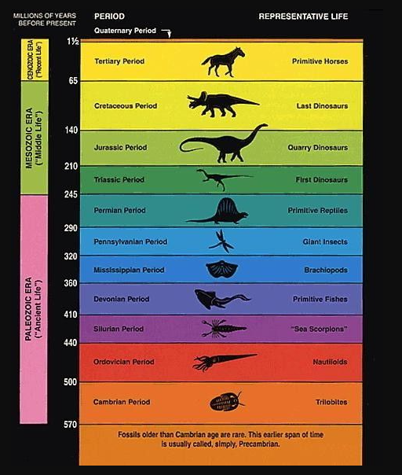

Cratons are the stable, ancient, and tectonically inactive interior regions of continents that form the oldest parts of the Earth's continental crust.

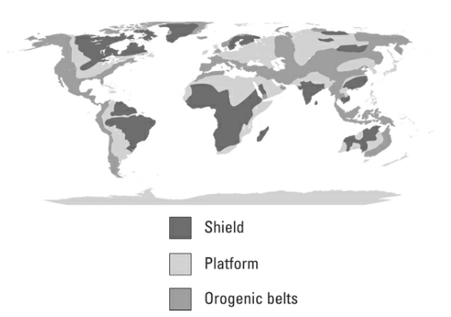

Photosynthesis: the biological process through which green plants transform sunlight, water, and carbon dioxide into oxygen and energy. The plants use the energy to grow and release the oxygen back into the atmosphere.

Stromatolites are mounded structures built by colonies of algae as they grow upward toward the sun. Stromatolites form when tiny strands of algae trap particles of sand and other sediments between them. These fossilized structures provide proof that photosynthetic organisms existed at the end of the Proterozoic eon.

Outgassing: eruptions of gas and water vapor from the earth’s atmosphere.

Photochemical disassociation: occurs when rays of sunlight hit water molecules in the atmosphere and break the molecular bonds.

Banded Iron Formation (BIF): a distinct type of sedimentary rock that is composed of alternating layers of iron oxides and silica-rich minerals, such as chert or quartz. These formations were primarily deposited in the Earth's oceans during the Precambrian era, between 3.8 and 1.8 billion years ago. Some scientists conclude that the formation of BIFs indicates that atmospheric oxygen levels at the end of the Archean eon and into the Proterozoic eon were fluctuating — increasing and decreasing and increasing again.

Black smokers: hydrothermal vents on the seafloor that scientists believe may have contributed to iron distribution in the oceans.

Ediacaran Fauna: a diverse assemblage of enigmatic, soft-bodied organisms that lived during the Ediacaran period, which spanned from around 635 to 541 million years ago.

Cambrian Explosion: refers to a relatively rapid diversification and emergence of complex life forms in the fossil record during the Cambrian period, which lasted from approximately 541 to 485 million years ago.

A body plan, also known as a Bauplan, refers to the fundamental structural and organizational features that characterize a particular group or lineage of organisms.

Exoskeletons: a rigid external structure that covers and protects the body of certain animals, primarily invertebrates. It was during the Cambrian that some organisms began developing these shells. They provided:

* Protection from the sun
* Moisture retention
* Muscular support
* Protection from predation

Arthropods are a major phylum of invertebrate animals characterized by their jointed appendages and segmented bodies. Trilobites are a famous example of an arthropod and are probably the organism most related to the Paleozoic. Spiders, lobsters, and crustaceans are modern-day arthropods.

Epicontinental seas: a shallow sea common in the Paleozoic.

Ammonoids are the spiral-shelled distant relatives of modern squid that flourished during the late Paleozoic.

Eurypterids: arthropods that looked like big scorpions, and were the first organisms to move into and adapt to freshwater environments.

Chordates: animals with nerve chords, which later evolved to vertebrates.

The Devonian period is sometimes called the “age of fish” due to the wide and diverse fossil record of fish variety during that time.

Endoskeletons: internal skeletons.

Cartilaginous: internal skeletons made of cartilage, rather than bone.

Bony fish during the Devonian were of two types: fish with fins, and lobe-fish- one of the first types of fish to breathe through their gills.

Amphibians: animals that breathe air, move comfortably outside water, yet spend the first part of their lives in water.

An amniote egg is an egg with a yolk sac inside it that provides nutrients to the developing embryo so that when it hatches from the egg, the animal is well past the larval stage and doesn’t need to live in water.

Cold- blooded: when animals have internal way of warming themselves.

Cellulose: a natural polysaccharide that is the main structural component of the cell walls of plants and some other organisms.

Conifers are a group of evergreen, cone-bearing trees and shrubs that belong to the phylum Gymnospermae. These are plants that reproduce using pollen and seeds, but without flowers.

The Paleozoic saw periods of intense mountain building, extensive glaciations, widespread shallow seas, and the continued buildup of material onto the continental cratons, building the continents into shapes resembling what you see today.

Sedimentary rocks formed in the ocean have a distinct pattern to their particle sizes, with sandstone created closer to shore in shallow water and limestone created farther away in deeper water.

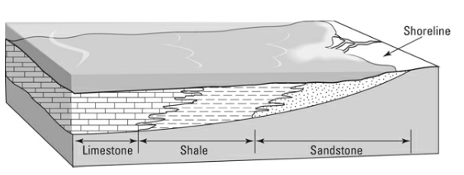

Marine transgression: a geological event during which sea level rises relative to the land and the shoreline moves toward higher ground, resulting in flooding of the land.

Marine regression: a geological event during which sea level decreases relative to the land, causing the shoreline to move seaward. This retreat of the sea from the land uncovers previously submerged areas, often leading to the deposition of terrestrial sediments over areas that were once underwater.